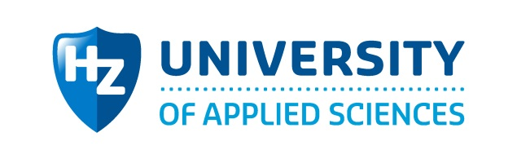

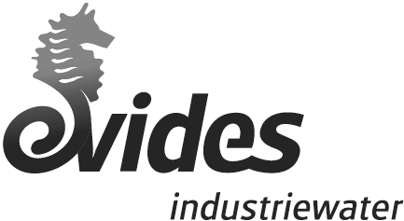

|  |  |
| --- | --- |
| From: | P. Vollaard & T. Steenbakker |
| Date: | 21 March 2016 |

# Introduction

The pilot started in November 2013 and will be in operation until March 2016. In this period three selected water streams will be tested in order to mild desalinate the water. The streams are taken from the biox effluent (this is also influent of deco), the basin (spuikom) and used cooling tower blow down (CTBD) water from Elsta. The water streams are treated by a flocculator/ lamella separator (FL+LS), UF (ultrafiltration) and then by a NF (Nanofiltration) or an EDR (electro dialysis reversal).

The goal of the E4water pilot is to determine the feasibility for mild desalination until 1 mS/cm at a low cost (target €0,4/ m3). This will be tested on the three previous mentioned water streams by a pre-treatment (consisting of coagulation, sedimentation and ultrafiltration) and two different desalination techniques (NF and EDR). By using the results of the pilot installation, a water stream(s) and a purification technique can be selected for a full-scale installation.

The applied techniques at the pilot plant can be divided into pre-treatment and mild-desalination. At the start of the project, the pre-treatment step is chosen to be the same for both nanofiltration (NF) and electrodialisys reversal (EDR). The robust pre-treatment will be optimized during the project and consists of:

* Coagulation
* Flocculation
* Lamella separation
* Ultrafiltration

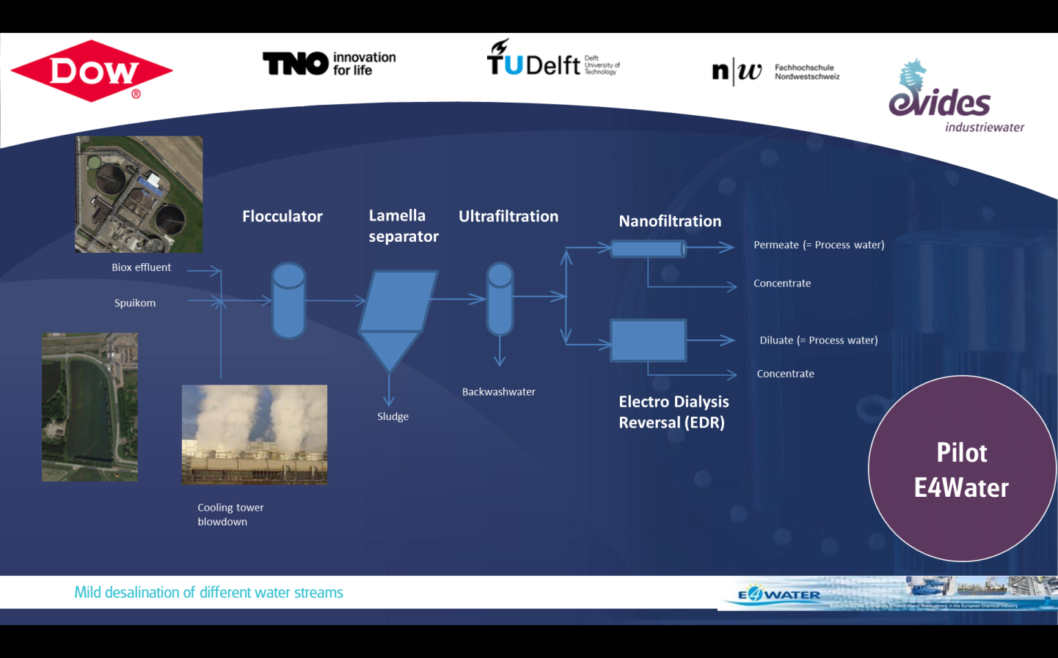

Figure 2.1: Schematic overview of the applied techniques at the pilot-plant E4-water with the three different feed-water sources.

The chosen techniques for the pilot demonstration are:

* Nanofiltration
* Electrodialisys reversal

The pre-treatment is focussed on the removal of Total Organic Carbon (TOC), ortho-phosphate, total phosphate and suspended solids. As a result, (bio) fouling on the downstream techniques (EDR, NF) can be limited to a certain extent.

A coagulant (Ferric Chloride) is added in order to destabilize colloidal particles. This coagulant is mixed intensively in an inline static mixer. After the coagulation and intensive mixing there is a slow mixing stage in which the coagulant can form stable flocks.

These stable flocks and present suspended solids can settle in the lamella separator. Due to the lamella (bundled plates) the surface of settling is enlarged, in such a way the efficiency of the settling process is increased. Remaining suspended solids are removed from the water by the Ultra Filtration (UF). In this process hollow membrane fibres are used to separate suspended solids. The UF is operated in the “dead-end” configuration, which means that all the feed water is filtrated through the membrane. After a certain filtration time the UF unit stops filtrating and is automatically flushed with produced permeate. During this flush chemicals can be added in order to clean the membrane more efficient. This is called a Chemical Enhanced Backwash (CEB) and is programmed at a certain frequency.

Nanofiltration (NF) is a membrane filtration process which is used for water softening, partly water desalination and removal of organics. Divalent ions, the larger monovalent ions and most of the organics are being removed. NF is widely applied on large scale for brackish water desalination, decolouring and softening. Nanofiltration is a pressure driven membrane process. The pore size of the membranes are typically between 1-10 nm. The difference between reversed osmosis (RO) and nanofiltration is the difference in pore size. NF has less fine membranes, the feed pressure for a NF is there for generally lower than for a RO system. Pressure is applied on the brackish water and the water is pushed through a semipermeable membrane. The divalent ions, larger ions and organics remain in the concentrated stream. The filtered water (permeate) is collected at the other side of the membrane.

Challenges in nanofiltration are controlling scaling (salt deposits on the membrane) and biofouling (growth of bacteria in the spacer). Biofouling is also dependent on the applied pre-treatment. Chemicals are used to control the scaling in this mild desalination technique.

Electrodialysis (ED) is an electrical potential-driven separation process. Dissolved ions are separated from water through ion permeable membranes under the influence of an electrical potential gradient. Ion exchange membranes selectively transport positive (cation exchange membranes, CEM) or negative (anion exchange membranes, AEM) ions and reject ions of the opposite charge. These membranes are arranged in an alternating way between the anode and cathode and an aqueous stream is introduced in between all membranes. With this configuration, positively charged cations migrate towards the cathode; they pass through the cation-exchange membrane and are rejected by the anion-exchange membrane. The opposite process occurs for anions in the feed water. Detailed process scheme can be found in [1].

EDR only removes charged ions. The essence of the technology is that the ions move (not the water molecules) through the membranes. EDR can be processed in a continuous operation mode. The concentrate stream can be recirculated over the membranes to increase the recovery. The direction of ion flow can be changed by reversing the polarity of the electrodes. Salts and other components are released from the ion exchange membranes using this mode of operation. EDR is claimed to be a self-cleaning process and therefore reduce the need for cleaning, using less chemicals and less pumping power compared to NF/RO.[5]

**2. Activities**

The activities executed at the E4Water pilot are varied. Overall the activities can be divided between operational- and reporting activities. The main goal of the activities is to optimize the pilot, maintain the equipment and monitoring of trends and taking appropriate actions if necessary.

## 2.1 Operational activities

The operational activities at the E4Water project are composed of a wide range of different activities like:

* Cleaning in place of treatment systems which means that one of the treatment steps is cleaned using chemicals.
* Refilling of chemicals required for operating the pilot.
* Calibration of online quality measurements.
* Fixing unforeseen events like leakages.

## 2.2 Reporting activities The reporting activities at the E4Water project are composed of (short) researches relating to one specific part of the pilot and biweekly reports about the activities of the pilot and the performance of all the treatment steps. The researches which are executed are:

* Screening of lamella separator using Elsta cooling tower blowdown as water source.
* Seasonal variations in feed water quality of the three different water sources
* Comparison between Westelijke Rijkswaterleiding and the Lovenpolder with used water sources.
* Evaluation of DOW and Inge membranes in the UF using Matlab.
* Comparison between the performance of two different nanofiltration membranes namely NF90-4040 and NF270-4040.
* Evaluation of the cleaning in place (CIP) resuls of the ultrafiltration (UF), nanofiltration (NF) and electrodialysis reversal (EDR).
* [Calcium, potassium, sodium, nitrate and TOC removal and or accumulation during the EDR treatment and reversal of the polarity](http://livelink/livelinksa2/llisapi.dll?func=ll&objId=70212639&objAction=Open&nexturl=%2Flivelinksa2%2Fllisapi%2Edll%3Ffunc%3Dll%26objId%3D66154114%26objAction%3Dbrowse%26viewType%3D1)

Furthermore, some more researches are executed by students from the HZ University of Applied Sciences. The researches which are executed by students are:

* Enhancing the biodegradability of cooling tower blowdown using advanced oxidation processes (AOP’s).
* **TITEL VAN ONDERZOEK PAUL**

**3. Knowledge development & Valorisation**

A lot of operational and technical knowledge is attained throughout the project. This operational and technical knowledge can be useful in treating other industrial water streams with different compositions. There may also be a link to other industries such as the drinking water industry, food processing industry or agriculture whereby the acquired knowledge can be useful.

A few examples of knowledge which is developed at the pilot and which can be valorised by other parties are:

* Technical and operational knowledge and experience of different (mild) desalinating techniques and advanced oxidation processes for the treatment of (industrial) water streams.
* Most appropriate pre-treatment for nanofiltration and electrodialysis reversal using different water sources.
* Objective quality parameters for determining the performance of different purification steps.
* Most suitable ultrafiltration and nanofiltration membranes for treating cooling tower blowdown.

**4. Significant results**

Based on the results produced throughout the project some significant results can be stated.

* The total organic carbon (TOC) removal by the EDR is not satisfactory enough to reach a TOC concentration lower than the maximum allowed concentration of 15mg/L for cooling tower make up water.
* The NF cannot cope with cooling tower blowdown. Substances present in the cooling tower blowdown create irreversible fouling on the membrane surface of the nanofiltration.
* Advanced oxidation processes followed by biological treatment is not sensible for treating cooling tower blowdown.
* With all three water sources a conductivity lower than 1,0mS/cm can be achieved for the two desalinating techniques (NF&EDR).
* Fe dosage does have a positive effect on the TMP level for Spuikom and Biox water a has a negative effect on the TMP level for Elsta.